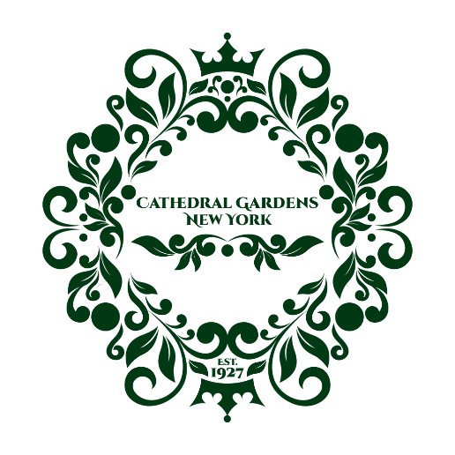

March 12, 2025

Dear neighbor,
We wanted to take a moment to thank everyone who attended our first community meeting of the new year last night. Your participation and engagement mean so much to us!
A special thank you to our guest speaker, Robert Hines, Manager of Community Affairs at NYRA, who did a fantastic job addressing many questions regarding the Belmont Park Redevelopment Project.
A few key topics we discussed last night included:
- Introduction of Board Members: We welcomed our new board members for the 2025 calendar year:
  - Regina Todd, President
  - Katie Rooney, Vice President
  - Anne Festa, Recording Secretary
  - Christina McCabe, Treasurer
  - Additionally, we welcomed a new board member, Tom Ollquist, a lifelong resident of Cathedral Gardens, and returning board members, Glenn Barnett and Eileen Vogel.
- Tree Planting Initiative: We have planted 25 new trees to date. We plan to plant 15 more trees in the neighborhood this fall. Additionally, we are working with the Town of Hempstead and Nassau County to have additional trees planted on the Hempstead side of Cathedral Gardens and down Westminster Road.
- New Flags for Westminster Road: We will be purchasing new flags to enhance our community’s appearance.
- Hanging Baskets: We are committed to continuing this initiative, provided we have volunteers to water them regularly.
- Heathwood Project: The project remains on schedule, with leasing set to begin this fall.
- Community Event Attendance: We discussed ways to improve participation in our social events and attendance at our community meetings. Some great ideas were brought to the table, and we are open to exploring new strategies moving forward to increase engagement.
- Dues Campaign: Our Dues Campaign for 2025 has come to a close! We raised $7,500.00 this year, and all of that money will be used to fund our community projects. Thank you to everyone who contributed!
- Street Sign Painting: We are looking for volunteers to help us paint some of the street sign poles where the green has faded. Additionally, we would like to try to straighten out the poles that are leaning to one side. If you’re interested in helping, please let us know!
- Welcome Wagon: Our Welcome Wagon visits new neighbors in Cathedral Gardens to offer a warm welcome and share community information. If you notice a new resident on your block, please email us at email@cathedralgardenscivicassociation.com to let us know. We currently rely on Zillow, which isn’t always accurate, so your help in keeping us informed would be greatly appreciated!
Additionally, there are two topics we didn’t get to discuss last night but want to acknowledge:
- Block Captains: Thank you to all of our Block Captains for their dedication in distributing this year’s campaign letters. Your efforts were instrumental in our success, and we truly appreciate your support! We are also looking for additional Block Captains—if you're interested in getting involved and making a difference in our community, please reach out to us.
- Spring Garage Sale: If you're interested in participating in this year’s Spring Garage Sale, please let us know.
Thank you again for your time and input. We look forward to working together to make our community even better!

